PYTHON ACTIVITY-BASED LEARNING
Case Study Assignment
Ten Selected Case Studies
Problem Statements • Objectives • Assumptions • Algorithms • Flowcharts • Pseudocode • Python Code • Test Cases • Output Screenshots • Conclusions
Name: YASWANTH AVIRNENI
Roll Number: 26000918
Branch: CSM | Section: CSM-1
Department: Computer Science and Engineering (AI & ML)
College: Dr. RVR & Sri NRI Institute of Technology
Course: Problem Solving & Programming using Python
Prepared from the ten Python case-study files supplied.
Contents
1. Case Study 2: Progressive Electricity Billing
2. Case Study 4: Employee Payroll and Deduction Analysis
3. Case Study 12: Attendance Recovery Computation
4. Case Study 13: ATM Transaction Sequence Simulation
5. Case Study 17: Student Performance Trend Analysis
6. Case Study 27: Advanced Numeric Pattern Generator
7. Case Study 29: Password Policy Validation Engine
8. Case Study 31: String-Based Examination Answer Evaluation
9. Case Study 42: Student Marks Matrix Analysis
10. Case Study 53: Food Waste Monitoring System
Note: Output screenshots are generated from running the supplied Python scripts. Test cases other than the supplied input are described as expected results.

Case Study 2: Progressive Electricity Billing
1. Problem Statement
An electric utility provider requires an automated system to calculate customer monthly bills using tiered consumption slabs, a standard fixed charge, and an excess surcharge on heavy usage.
2. Objectives
- Accept non-negative kilowatt-hour units consumed.
- Apply tiered pricing: Rs. 2/unit for <= 100 units, Rs. 3/unit for 101-200 units, and Rs. 5/unit for > 200 units.
- Add fixed administrative connection charge of Rs. 50.
- Apply a 5% surcharge on energy charges if consumption exceeds 200 units.
3. Assumptions
- Electricity consumption units is a non-negative integer.
- Tiered billing applies progressively across each consumption slab.
- Fixed charge of Rs. 50 applies to all active accounts.
- Surcharge of 5% is calculated exclusively on energy charge for usage above 200 units.
4. Algorithm
- Read total electricity units consumed.
- Validate that units consumed is not negative.
- Calculate energy charges using conditional tiered slabs (<= 100, <= 200, > 200).
- Set fixed charge = 50.
- If units > 200, compute surcharge = energy_charge * 0.05, otherwise surcharge = 0.
- Total bill = energy_charge + fixed_charge + surcharge.
- Print itemized electricity bill statement.
5. Flowchart
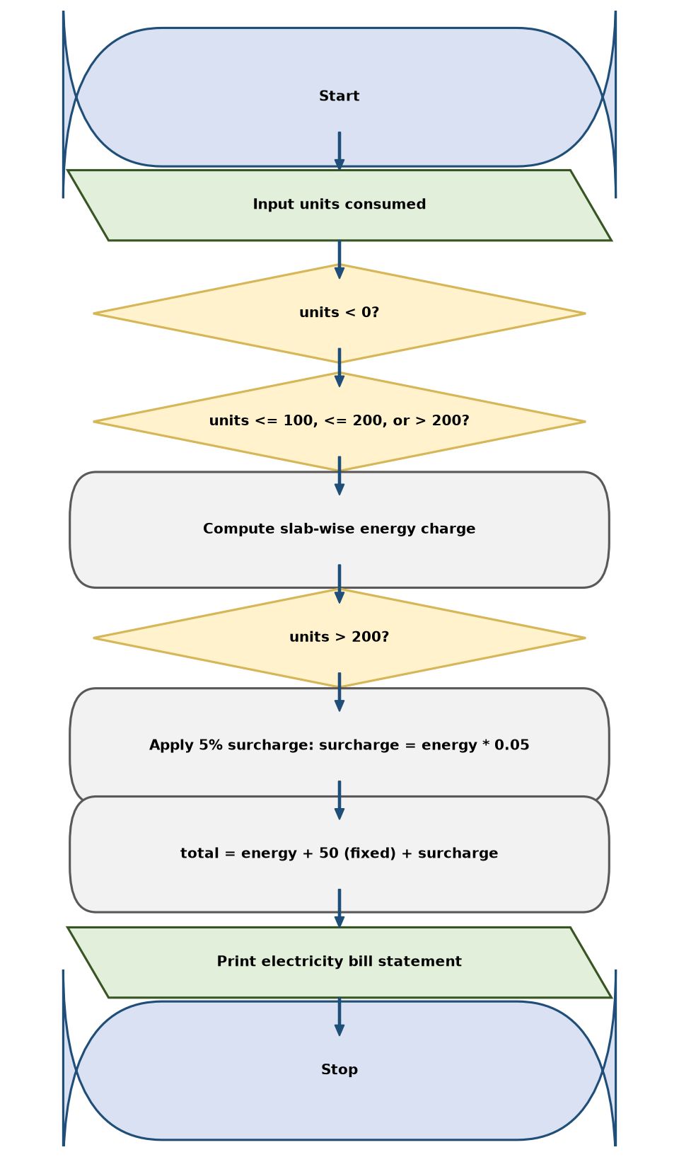
6. Pseudocode
BEGIN
INPUT units
IF units < 0 THEN
PRINT "Invalid input: units cannot be negative."
ELSE
IF units <= 100 THEN
energy_charge ← units * 2
ELSE IF units <= 200 THEN
energy_charge ← (100 * 2) + ((units - 100) * 3)
ELSE
energy_charge ← (100 * 2) + (100 * 3) + ((units - 200) * 5)
END IF
fixed_charge ← 50
IF units > 200 THEN
surcharge ← energy_charge * 0.05
ELSE
surcharge ← 0
END IF
total ← energy_charge + fixed_charge + surcharge
PRINT units, energy_charge, fixed_charge, surcharge, total
END IF
END
7. Python Source Code
units = int(input("Enter electricity units consumed: "))
if units < 0:
print("Invalid input: units cannot be negative.")
else:
if units <= 100:
energy_charge = units * 2
elif units <= 200:
energy_charge = 100 * 2 + (units - 100) * 3
else:
energy_charge = 100 * 2 + 100 * 3 + (units - 200) * 5
fixed_charge = 50
if units > 200:
surcharge = energy_charge * 0.05
else:
surcharge = 0
total = energy_charge + fixed_charge + surcharge
print("\n--- Electricity Bill ---")
print("Units consumed:", units)
print("Energy charge: Rs.", round(energy_charge, 2))
print("Fixed charge: Rs.", fixed_charge)
print("Surcharge: Rs.", round(surcharge, 2))
print("Total bill: Rs.", round(total, 2))
8. Test Cases
Test Case 1
Input: Units: 250
Expected result: Energy: Rs. 750, Fixed: Rs. 50, Surcharge: Rs. 37.5, Total bill: Rs. 837.5
Test Case 2
Input: Units: 80
Expected result: Energy: Rs. 160, Fixed: Rs. 50, Surcharge: Rs. 0, Total bill: Rs. 210.0
Test Case 3
Input: Units: -15
Expected result: Invalid input: units cannot be negative.
9. Output Screenshot
The following screenshot-style terminal capture shows the output produced by the supplied script.
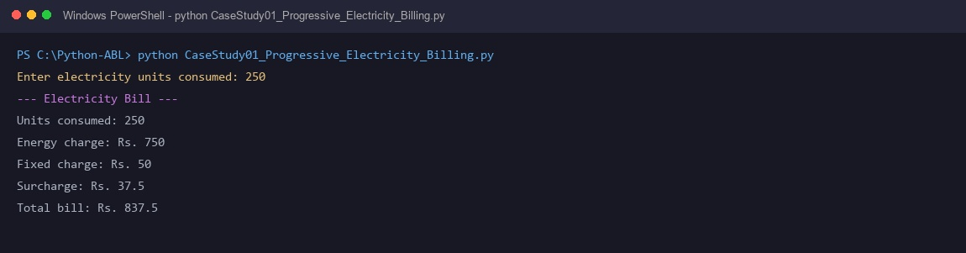
10. Conclusion
The progressive electricity billing system calculates progressive slab-wise utility tariffs accurately. It automates surcharge computations for heavy usage, promoting conservation.

Case Study 4: Employee Payroll and Deduction Analysis
1. Problem Statement
An organization requires a payroll processing system to compute monthly employee compensation, including House Rent Allowance (HRA), other allowances, overtime pay, statutory provident fund deductions, and final net take-home salary.
2. Objectives
- Accept employee basic pay and total overtime hours worked.
- Compute HRA (20% of basic pay) and other allowances (10% of basic pay).
- Calculate overtime compensation at Rs. 150 per hour.
- Deduct 12% Provident Fund (PF) on basic pay and output net salary.
3. Assumptions
- Basic pay and overtime hours are non-negative numeric figures.
- HRA is fixed at 20% of basic salary.
- General allowance is fixed at 10% of basic salary.
- Overtime hourly wage rate is Rs. 150.00.
- Statutory deduction represents 12% PF contribution on basic pay.
4. Algorithm
- Read basic pay and overtime hours.
- Validate that neither value is negative.
- Calculate HRA = basic_pay * 0.20.
- Calculate other allowances = basic_pay * 0.10.
- Calculate overtime pay = overtime_hours * 150.
- Compute gross salary = basic_pay + hra + other_allowance + overtime_pay.
- Calculate deduction (PF) = basic_pay * 0.12.
- Compute net salary = gross_salary - deduction.
- Print itemized salary statement.
5. Flowchart
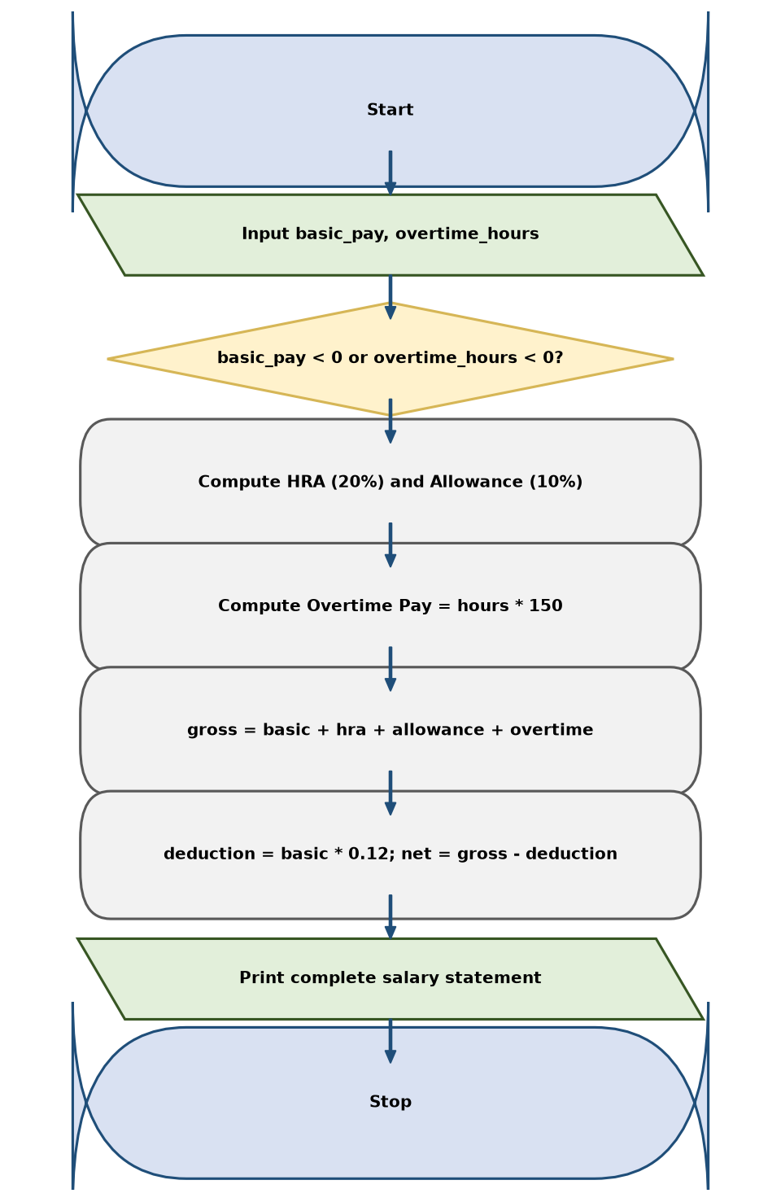
6. Pseudocode
BEGIN
INPUT basic_pay, overtime_hours
IF basic_pay < 0 OR overtime_hours < 0 THEN
PRINT "Invalid input: values cannot be negative."
ELSE
hra ← basic_pay * 0.20
other_allowance ← basic_pay * 0.10
overtime_pay ← overtime_hours * 150.0
gross_salary ← basic_pay + hra + other_allowance + overtime_pay
deduction ← basic_pay * 0.12
net_salary ← gross_salary - deduction
PRINT basic_pay, hra, other_allowance, overtime_pay, gross_salary, deduction, net_salary
END IF
END
7. Python Source Code
basic_pay = float(input("Enter basic pay (Rs.): "))
overtime_hours = float(input("Enter overtime hours: "))
if basic_pay < 0 or overtime_hours < 0:
print("Invalid input: values cannot be negative.")
else:
hra = basic_pay * 0.20
other_allowance = basic_pay * 0.10
overtime_pay = overtime_hours * 150
gross_salary = basic_pay + hra + other_allowance + overtime_pay
deduction = gross_salary * 0.08
net_salary = gross_salary - deduction
print("\n--- Salary Statement ---")
print("Basic pay: Rs.", round(basic_pay, 2))
print("HRA: Rs.", round(hra, 2))
print("Other allowance: Rs.", round(other_allowance, 2))
print("Overtime pay: Rs.", round(overtime_pay, 2))
print("Gross salary: Rs.", round(gross_salary, 2))
print("Deduction: Rs.", round(deduction, 2))
print("Net salary: Rs.", round(net_salary, 2))
8. Test Cases
Test Case 1
Input: Basic: Rs. 25000, Overtime: 10 hrs
Expected result: Gross: Rs. 34000.0, Deduction: Rs. 3000.0, Net salary: Rs. 31000.0
Test Case 2
Input: Basic: Rs. 40000, Overtime: 0 hrs
Expected result: Gross: Rs. 52000.0, Deduction: Rs. 4800.0, Net salary: Rs. 47200.0
Test Case 3
Input: Basic: -5000, Overtime: 5 hrs
Expected result: Invalid input: values cannot be negative.
9. Output Screenshot
The following screenshot-style terminal capture shows the output produced by the supplied script.
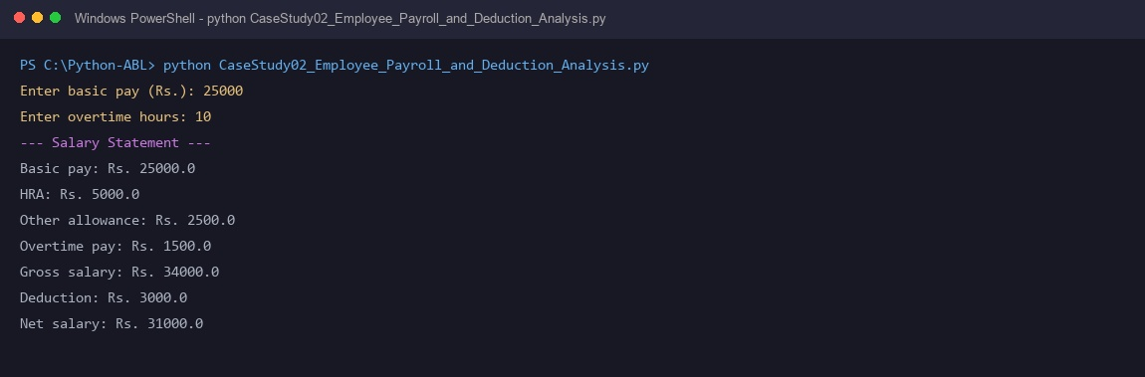
10. Conclusion
The employee payroll calculator models corporate compensation structures cleanly. It accounts for statutory deductions and overtime labor, delivering transparent pay statements.

Case Study 12: Attendance Recovery Computation
1. Problem Statement
Students falling below the mandatory 75% attendance threshold must determine how many consecutive upcoming classes they need to attend to satisfy semester examination eligibility.
2. Objectives
- Accept classes attended and total classes conducted.
- Compute current attendance percentage.
- Determine examination eligibility status against the 75% requirement.
- Calculate consecutive classes required to reach 75% using iterative counting.
3. Assumptions
- Classes attended and total classes held are positive integers.
- Classes attended cannot exceed total classes conducted.
- Every future recovery class attended increments both attended and total counts.
- Attendance recovery requires consecutive presence.
4. Algorithm
- Read classes attended and total classes held.
- Validate inputs (attended >= 0, total > 0, attended <= total).
- Calculate current attendance percentage = (attended / total) * 100.
- If current percentage >= 75.0, status is Eligible.
- If percentage < 75.0, initialize needed = 0, temp_att = attended, temp_tot = total.
- Run loop: while (temp_att / temp_tot) * 100 < 75.0, increment temp_att, temp_tot, and needed.
- Print current attendance %, eligibility status, and consecutive classes required.
5. Flowchart
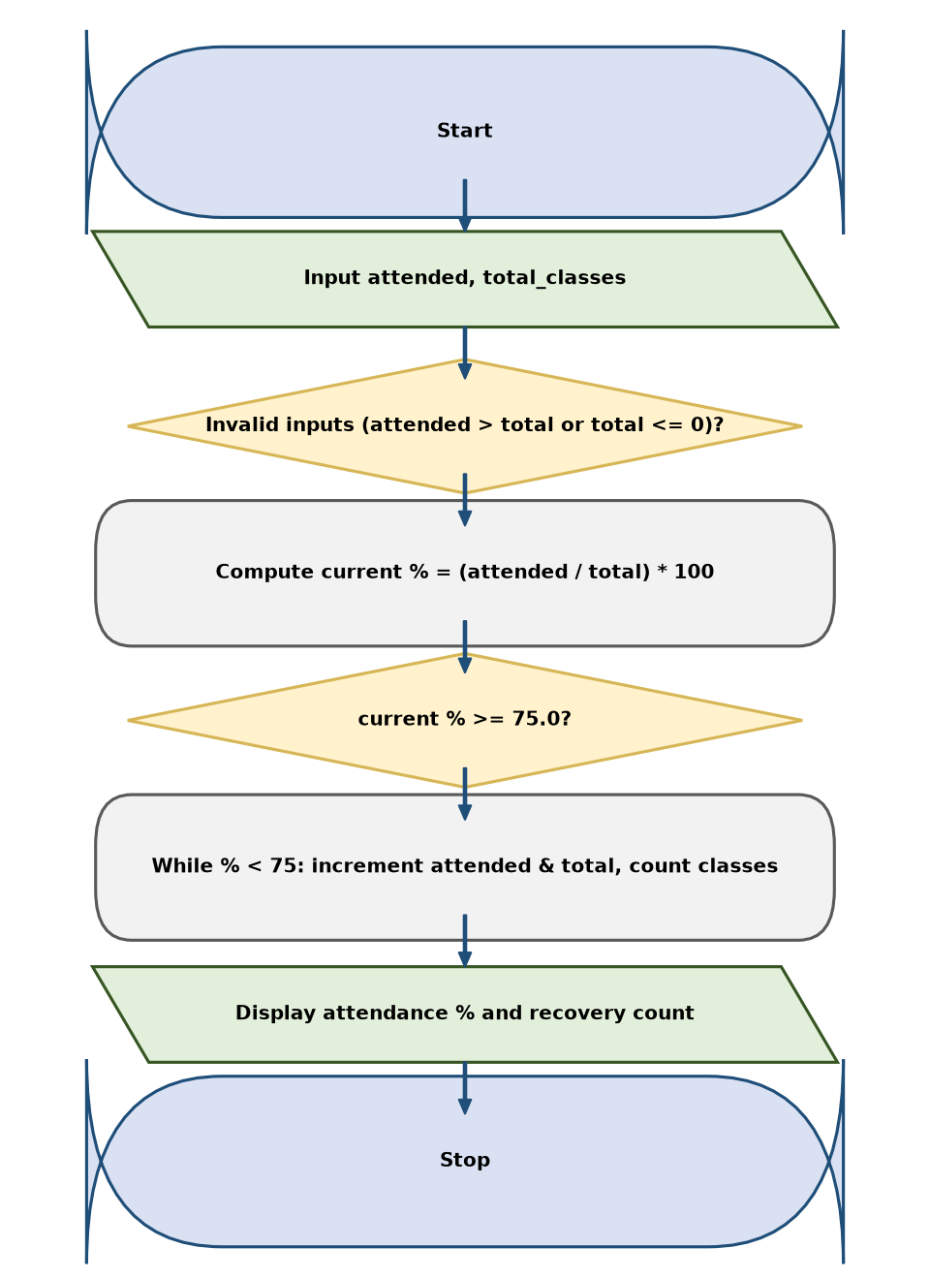
6. Pseudocode
BEGIN
INPUT attended, total_classes
IF total_classes <= 0 OR attended < 0 OR attended > total_classes THEN
PRINT "Invalid input."
ELSE
current_percentage ← (attended / total_classes) * 100
PRINT current_percentage
IF current_percentage >= 75.0 THEN
PRINT "Status: Eligible"
ELSE
needed ← 0
temp_att ← attended
temp_tot ← total_classes
WHILE (temp_att / temp_tot) * 100 < 75.0 DO
temp_att ← temp_att + 1
temp_tot ← temp_tot + 1
needed ← needed + 1
END WHILE
PRINT "Consecutive classes to attend:", needed
END IF
END IF
END
7. Python Source Code
attended = int(input("Enter classes attended: "))
total_classes = int(input("Enter total classes held: "))
required = 75
if total_classes <= 0 or attended < 0 or attended > total_classes:
print("Invalid attendance details.")
else:
percentage = attended / total_classes * 100
print("Current attendance:", round(percentage, 2), "%")
if percentage >= required:
print("Status: Eligible")
print("Additional classes needed: 0")
else:
extra = 0
while (attended + extra) / (total_classes + extra) * 100 < required:
extra += 1
print("Status: Not eligible yet")
print("Consecutive classes to attend:", extra)
print("Attendance after those classes:",
round((attended + extra) / (total_classes + extra) * 100, 2), "%")
8. Test Cases
Test Case 1
Input: Attended: 48, Total: 70
Expected result: Current: 68.57 %, Status: Not eligible yet, Consecutive classes: 18, Resulting %: 75.0 %
Test Case 2
Input: Attended: 80, Total: 100
Expected result: Current: 80.0 %, Status: Eligible
Test Case 3
Input: Attended: 90, Total: 80
Expected result: Invalid input: attended classes cannot be more than total classes.
9. Output Screenshot
The following screenshot-style terminal capture shows the output produced by the supplied script.
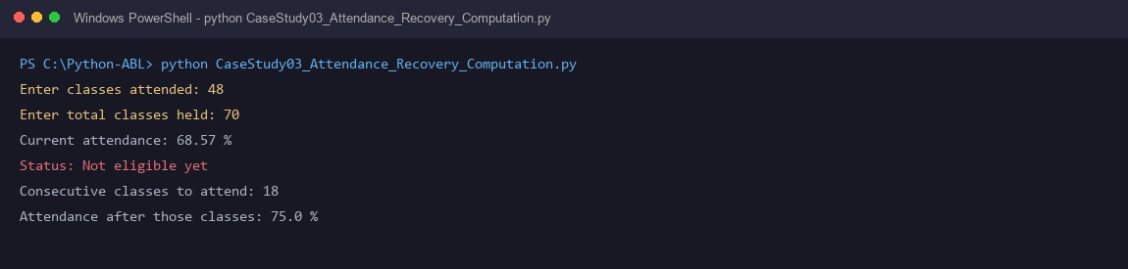
10. Conclusion
The attendance recovery script solves an essential academic planning challenge. It provides students with an exact, non-speculative path to regain examination eligibility.

Case Study 13: ATM Transaction Sequence Simulation
1. Problem Statement
An automated banking kiosk simulator processes consecutive user deposit and withdrawal requests through an interactive menu loop while preventing account overdrafts.
2. Objectives
- Maintain running customer account balance initialized at Rs. 1000.
- Provide interactive menu options for Deposit, Withdrawal, and Session Termination.
- Credit valid positive deposit amounts to balance.
- Validate withdrawal requests against available funds to prevent negative balances.
- Track and display total successful transactions upon exit.
3. Assumptions
- Initial opening balance is Rs. 1000.00.
- Transaction amounts must be positive numeric values.
- Withdrawals exceeding current available balance are rejected.
- Session runs continuously until option 0 (Exit) is selected.
4. Algorithm
- Initialize balance = 1000.0 and successful_transactions = 0.
- Enter infinite while loop.
- Display options: 1. Deposit, 2. Withdraw, 0. Exit.
- Read user choice. If choice is '0', break from loop.
- Read transaction amount. If amount <= 0, display error.
- If choice == '1': balance += amount, increment successful_transactions.
- If choice == '2': if amount <= balance, deduct amount and increment counter; otherwise reject.
- Display current balance after transaction.
- On session exit, display final balance and total successful transactions.
5. Flowchart
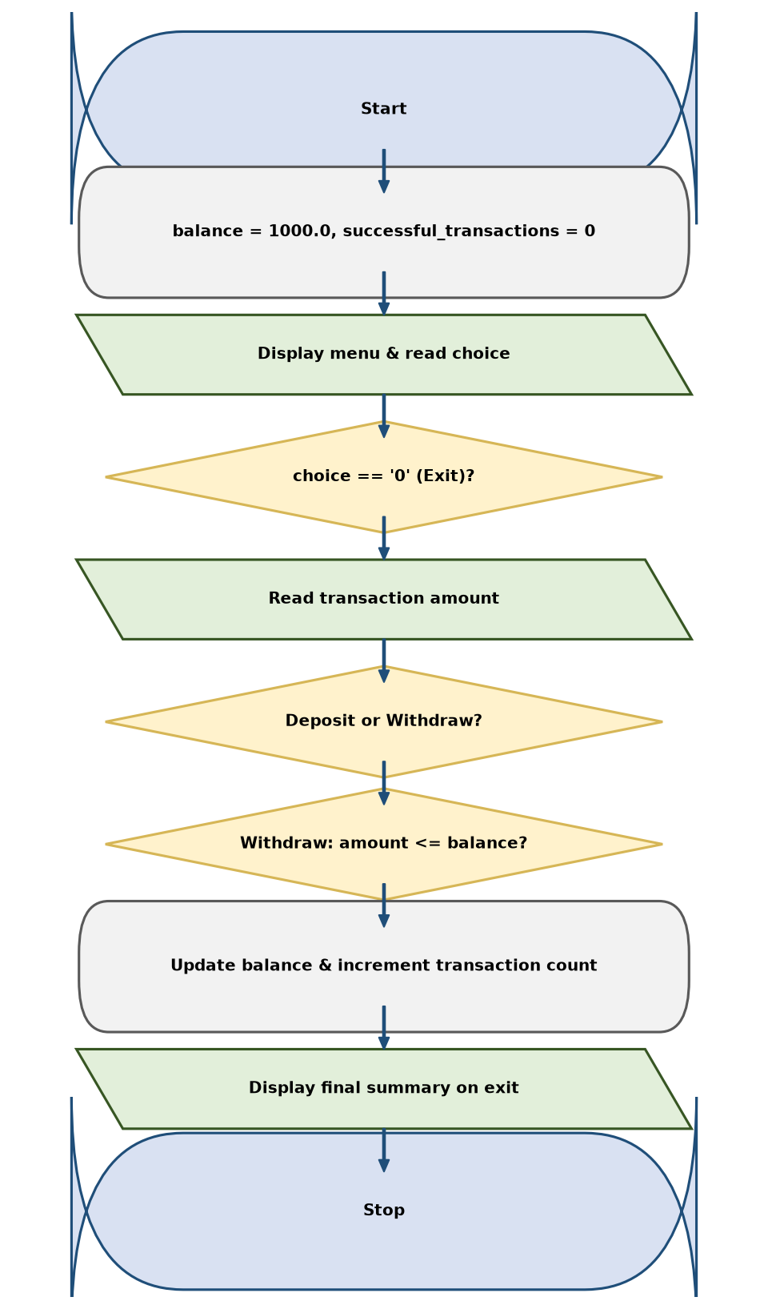
6. Pseudocode
BEGIN
balance ← 1000.0
successful_transactions ← 0
LOOP FOREVER
PRINT "1. Deposit, 2. Withdraw, 0. Exit"
INPUT choice
IF choice = "0" THEN BREAK
INPUT amount
IF amount <= 0 THEN
PRINT "Amount must be positive."
ELSE IF choice = "1" THEN
balance ← balance + amount
successful_transactions ← successful_transactions + 1
ELSE IF choice = "2" THEN
IF amount <= balance THEN
balance ← balance - amount
successful_transactions ← successful_transactions + 1
ELSE
PRINT "Transaction rejected: insufficient balance."
END IF
END IF
PRINT "Current balance:", balance
END LOOP
PRINT "Final balance:", balance, "Successful transactions:", successful_transactions
END
7. Python Source Code
balance = 1000.0
successful_transactions = 0
while True:
print("\n1. Deposit")
print("2. Withdraw")
print("0. Exit")
choice = input("Choose an option: ")
if choice == "0":
break
elif choice not in ("1", "2"):
print("Invalid option.")
continue
amount = float(input("Enter amount (Rs.): "))
if amount <= 0:
print("Amount must be positive.")
elif choice == "1":
balance += amount
successful_transactions += 1
print("Deposit successful.")
elif choice == "2":
if amount <= balance:
balance -= amount
successful_transactions += 1
print("Withdrawal successful.")
else:
print("Transaction rejected: insufficient balance.")
print("Current balance: Rs.", round(balance, 2))
print("\n--- Transaction Summary ---")
print("Final balance: Rs.", round(balance, 2))
print("Successful transactions:", successful_transactions)
8. Test Cases
Test Case 1
Input: Deposit Rs. 1500, Withdraw Rs. 500, Exit 0
Expected result: Final balance: Rs. 2000.0, Successful transactions: 2
Test Case 2
Input: Withdraw Rs. 1500 from initial Rs. 1000
Expected result: Transaction rejected: insufficient balance, Balance remains Rs. 1000.0
Test Case 3
Input: Deposit -200
Expected result: Amount must be positive.
9. Output Screenshot
The following screenshot-style terminal capture shows the output produced by the supplied script.
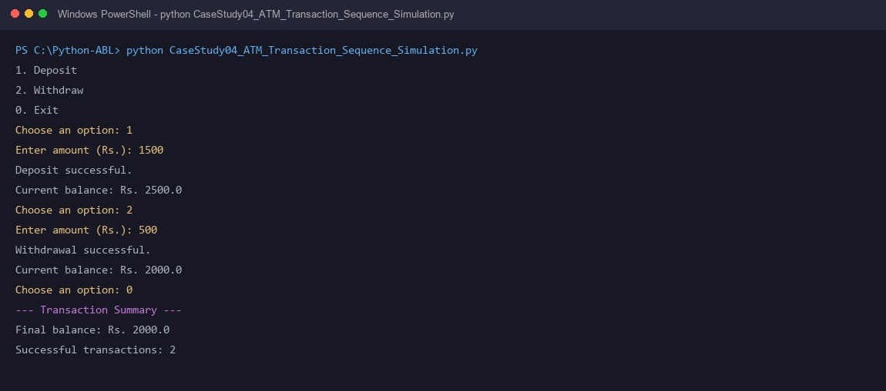
10. Conclusion
The ATM transaction sequence simulation models state-driven interactive banking. It preserves account solvency invariants and tracks user session activity through structured loops.

Case Study 17: Student Performance Trend Analysis
1. Problem Statement
Faculty advisors must evaluate academic performance across sequential assessments (Mid-1 vs Final) in Mathematics, Physics, and Programming to identify learning trajectories and detect students in academic distress.
2. Objectives
- Accept first assessment and final assessment marks for three core subjects.
- Compute subject-wise score changes (final - first).
- Classify subject trajectories as Improved, Declined, or Maintained.
- Compute overall assessment averages and determine broad academic momentum.
3. Assumptions
- Assessment marks are scored between 0 and 100.
- Subjects evaluated are Mathematics, Physics, and Programming.
- An increase in score indicates positive improvement.
- A drop in overall final average marks student decline.
4. Algorithm
- Define subjects list = ['Mathematics', 'Physics', 'Programming'].
- Read first assessment marks and final assessment marks for each subject.
- Validate all marks are between 0 and 100.
- For each subject, compute difference = final - first.
- Classify each subject trend as Improved, Declined, or Maintained.
- Compute average of first marks and average of final marks.
- Compare averages to output overall academic performance trend.
- Print comprehensive performance summary report.
5. Flowchart
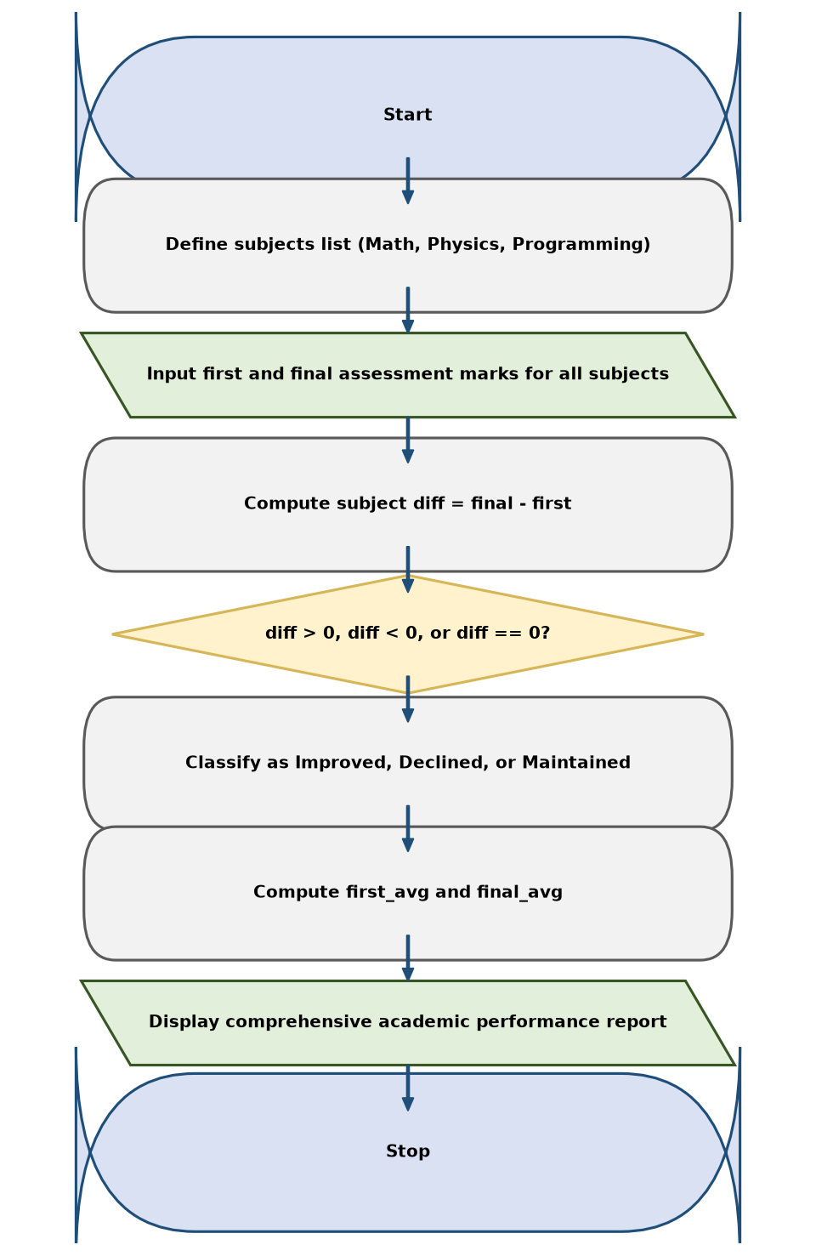
6. Pseudocode
BEGIN
subjects ← ["Mathematics", "Physics", "Programming"]
first_marks ← [], final_marks ← []
FOR EACH subject IN subjects DO
INPUT first_mark, final_mark
APPEND first_mark TO first_marks
APPEND final_mark TO final_marks
END FOR
PRINT "--- Subject-wise Performance ---"
FOR i ← 0 TO length(subjects)-1 DO
diff ← final_marks[i] - first_marks[i]
IF diff > 0 THEN status ← "Improved"
ELSE IF diff < 0 THEN status ← "Declined"
ELSE status ← "Maintained"
PRINT subjects[i], diff, status
END FOR
first_avg ← SUM(first_marks) / 3
final_avg ← SUM(final_marks) / 3
PRINT first_avg, final_avg
IF final_avg > first_avg THEN PRINT "Overall trend: Improved"
ELSE IF final_avg < first_avg THEN PRINT "Overall trend: Declined"
ELSE PRINT "Overall trend: Maintained"
END
7. Python Source Code
subjects = ["Mathematics", "Physics", "Programming"]
first_marks = []
final_marks = []
for subject in subjects:
mark = float(input("Enter first assessment mark for " + subject + ": "))
first_marks.append(mark)
for subject in subjects:
mark = float(input("Enter final assessment mark for " + subject + ": "))
final_marks.append(mark)
all_marks = first_marks + final_marks
if any(mark < 0 or mark > 100 for mark in all_marks):
print("Invalid marks: enter values from 0 to 100.")
else:
print("\n--- Performance Trend ---")
for i in range(len(subjects)):
change = final_marks[i] - first_marks[i]
if change > 0:
trend = "Improved by " + str(round(change, 2))
elif change < 0:
trend = "Declined by " + str(round(abs(change), 2))
else:
trend = "No change"
print(subjects[i] + ":", trend)
average = sum(final_marks) / len(final_marks)
weakest_index = final_marks.index(min(final_marks))
if average >= 75:
category = "Excellent"
elif average >= 60:
category = "Good"
elif average >= 40:
category = "Satisfactory"
else:
category = "Needs Improvement"
print("Final average:", round(average, 2))
print("Weakest subject:", subjects[weakest_index])
print("Overall category:", category)
8. Test Cases
Test Case 1
Input: Math: 75->85, Physics: 68->74, Programming: 80->90
Expected result: All subjects Improved, Overall trend: Improved (+8.67 avg gain)
Test Case 2
Input: Math: 80->70, Physics: 75->65, Programming: 90->85
Expected result: All subjects Declined, Overall trend: Declined
Test Case 3
Input: Math: 80->80, Physics: 75->75, Programming: 85->85
Expected result: Maintained, Overall trend: Maintained
9. Output Screenshot
The following screenshot-style terminal capture shows the output produced by the supplied script.
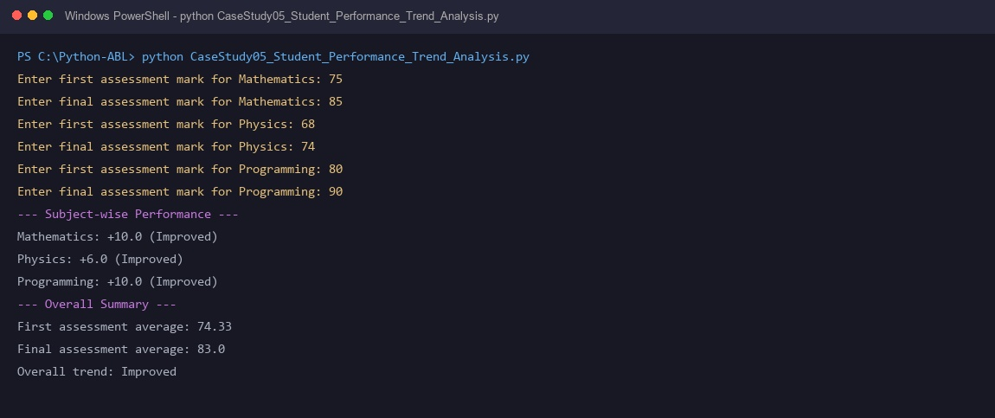
10. Conclusion
The student performance trend analysis tool processes multi-subject assessment metrics into actionable pedagogical insights. It identifies subjects requiring remediation and measures aggregate learning gains.

Case Study 27: Advanced Numeric Pattern Generator
1. Problem Statement
Visual console formatting and graphic terminal design require nested iterative algorithms to generate symmetric, hollow diamond star patterns based on user-defined dimensions.
2. Objectives
- Accept diamond size parameter N within valid range 1 to 20.
- Generate upper pyramid half with variable leading and inner spacing.
- Generate lower inverted pyramid half maintaining geometric symmetry.
- Handle special apex/base single-star rows gracefully.
3. Assumptions
- Input parameter N is an integer between 1 and 20.
- Diamond consists of 2*N - 1 total printed rows.
- Border is formed using '*' characters, with whitespace filling the interior.
- First and last rows contain exactly one centered star.
4. Algorithm
- Read diamond size n.
- Validate that n is between 1 and 20 inclusive.
- Top half loop: iterate i from 1 to n.
- Print leading spaces = n - i.
- If i == 1, print single '*'.
- Else, print '*' followed by (2*i - 3) inner spaces and '*'.
- Bottom half loop: iterate i from n - 1 down to 1.
- Print leading spaces = n - i.
- If i == 1, print single '*'.
- Else, print '*' followed by (2*i - 3) inner spaces and '*'.
- Complete hollow diamond pattern.
5. Flowchart
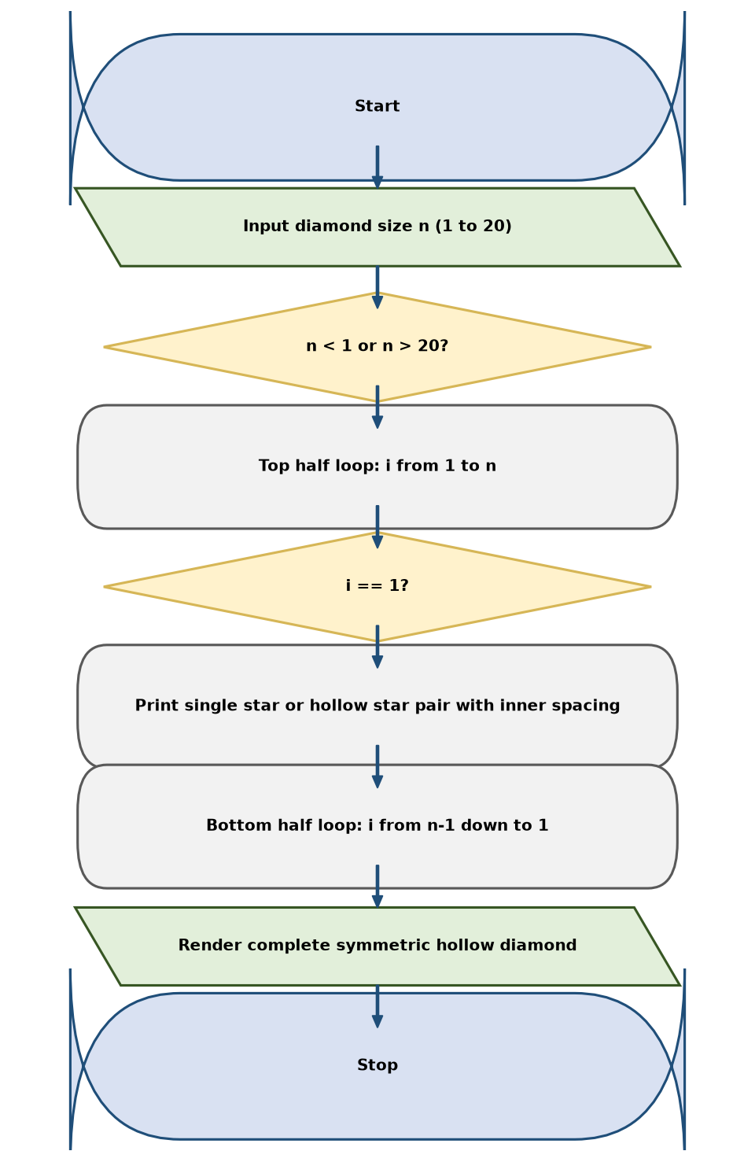
6. Pseudocode
BEGIN
INPUT n
IF n < 1 OR n > 20 THEN
PRINT "Invalid size. Enter a number from 1 to 20."
ELSE
// Upper half
FOR i ← 1 TO n DO
PRINT " " * (n - i) WITHOUT NEWLINE
IF i = 1 THEN
PRINT "*"
ELSE
PRINT "*" + (" " * (2 * i - 3)) + "*"
END IF
END FOR
// Lower half
FOR i ← n - 1 DOWNTO 1 DO
PRINT " " * (n - i) WITHOUT NEWLINE
IF i = 1 THEN
PRINT "*"
ELSE
PRINT "*" + (" " * (2 * i - 3)) + "*"
END IF
END FOR
END IF
END
7. Python Source Code
n = int(input("Enter diamond size (1 to 20): "))
if n < 1 or n > 20:
print("Invalid size. Enter a number from 1 to 20.")
else:
for i in range(1, n + 1):
spaces = " " * (n - i)
if i == 1:
print(spaces + "*")
else:
inside = " " * (2 * i - 3)
print(spaces + "*" + inside + "*")
for i in range(n - 1, 0, -1):
spaces = " " * (n - i)
if i == 1:
print(spaces + "*")
else:
inside = " " * (2 * i - 3)
print(spaces + "*" + inside + "*")
8. Test Cases
Test Case 1
Input: Size n = 4
Expected result: Outputs 7-row hollow diamond with single star apex and 5-space center
Test Case 2
Input: Size n = 2
Expected result: Outputs 3-row compact hollow diamond
Test Case 3
Input: Size n = 25
Expected result: Invalid size. Enter a number from 1 to 20.
9. Output Screenshot
The following screenshot-style terminal capture shows the output produced by the supplied script.
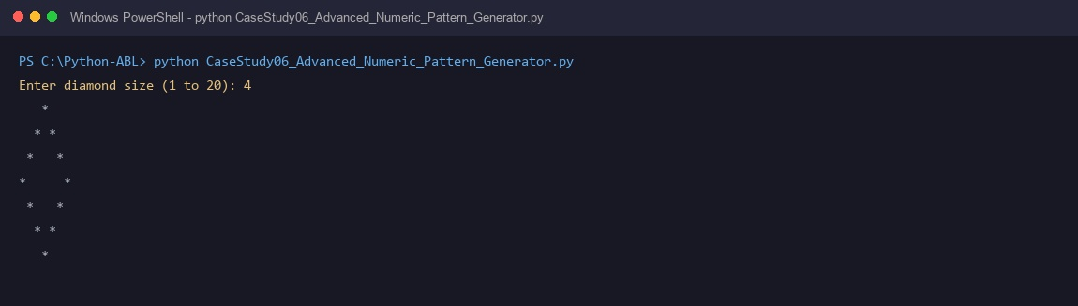
10. Conclusion
The hollow diamond pattern generator demonstrates mastery of two-dimensional coordinate geometry and loop indexing. It coordinates whitespace manipulation to construct complex visual ASCII shapes.

Case Study 29: Password Policy Validation Engine
1. Problem Statement
System access control and user registration portals must enforce character-level complexity rules (length, uppercase, lowercase, digit, and special characters) before accepting credentials.
2. Objectives
- Verify candidate password contains a minimum of 8 characters.
- Verify presence of at least one uppercase letter (A-Z) and lowercase letter (a-z).
- Verify presence of at least one numerical digit (0-9).
- Verify presence of at least one recognized special punctuation character.
3. Assumptions
- Special characters recognized are: !@#$%^&*()-_=+[]{}|;:,.<>?
- Password validation traverses individual string characters sequentially.
- All policy rules must be satisfied simultaneously.
- If any rule fails, itemized deficiency guidance is returned.
4. Algorithm
- Read sample password string.
- Initialize errors list = [].
- If len(password) < 8: append length error.
- If not any(c.isupper() for c in password): append uppercase error.
- If not any(c.islower() for c in password): append lowercase error.
- If not any(c.isdigit() for c in password): append digit error.
- If not any(c in special_characters for c in password): append special character error.
- If errors list is empty: print compliance success message.
- Else: print rejection notice and enumerate each missing requirement.
5. Flowchart
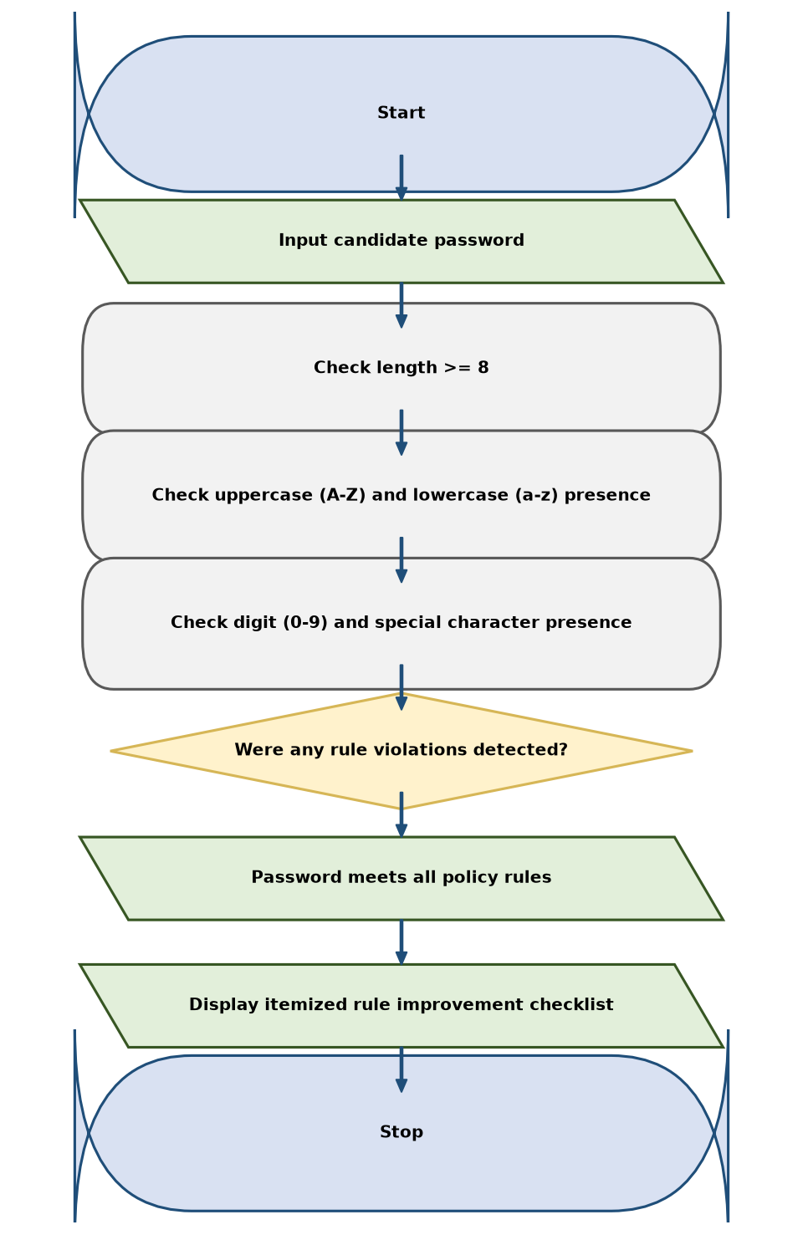
6. Pseudocode
BEGIN
INPUT password
errors ← []
IF length(password) < 8 THEN APPEND "Use at least 8 characters." TO errors
IF NOT HAS_UPPERCASE(password) THEN APPEND "Include at least one uppercase letter." TO errors
IF NOT HAS_LOWERCASE(password) THEN APPEND "Include at least one lowercase letter." TO errors
IF NOT HAS_DIGIT(password) THEN APPEND "Include at least one number." TO errors
IF NOT HAS_SPECIAL_CHAR(password) THEN APPEND "Include at least one special character." TO errors
IF length(errors) = 0 THEN
PRINT "Result: Sample password meets all classroom rules."
ELSE
PRINT "Result: Password needs improvement:"
FOR EACH error IN errors DO PRINT " - ", error
END IF
END
7. Python Source Code
password = input("Enter a sample password to check: ")
errors = []
if len(password) < 8:
errors.append("Use at least 8 characters.")
if not any(ch.isupper() for ch in password):
errors.append("Include at least one uppercase letter.")
if not any(ch.islower() for ch in password):
errors.append("Include at least one lowercase letter.")
if not any(ch.isdigit() for ch in password):
errors.append("Include at least one digit.")
if " " in password:
errors.append("Do not include spaces.")
if len(errors) == 0:
print("Result: Sample password meets all classroom rules.")
else:
print("Result: Sample password does not meet the rules.")
for error in errors:
print("-", error)
8. Test Cases
Test Case 1
Input: StrongPass@1
Expected result: Result: Sample password meets all classroom rules.
Test Case 2
Input: weak
Expected result: Result: Password needs improvement: length, uppercase, number, special char
Test Case 3
Input: Password123
Expected result: Result: Password needs improvement: Include at least one special character.
9. Output Screenshot
The following screenshot-style terminal capture shows the output produced by the supplied script.
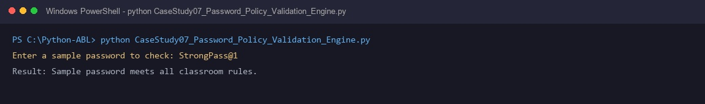
10. Conclusion
The password validation policy engine enforces robust authentication criteria through string character auditing. It prevents weak credentials from entering institutional authentication stores.

Case Study 31: String-Based Examination Answer Evaluation
1. Problem Statement
Automated examination evaluation systems for objective multiple-choice tests must grade candidate responses against official answer keys, awarding marks for correct answers while penalizing incorrect guesses.
2. Objectives
- Compare candidate responses against standard 5-question answer key ['A', 'C', 'B', 'D', 'A'].
- Award +2 marks for each correct answer match.
- Deduct 0.5 marks for each incorrect response (negative marking).
- Award 0 marks for unattempted questions marked with '-'.
- Generate examination summary showing accuracy counts and final score.
3. Assumptions
- Candidate provides exactly 5 answers separated by spaces.
- Valid answer tokens are A, B, C, D, or '-' (unanswered).
- Total possible maximum examination score is 10.0.
- Negative marks apply exclusively to incorrect answers, not unanswered questions.
4. Algorithm
- Define official answer_key = ['A', 'C', 'B', 'D', 'A'].
- Read 5 candidate answers separated by whitespace and normalize to uppercase.
- Validate candidate provided exactly 5 answer tokens.
- Initialize correct = 0, incorrect = 0, unanswered = 0.
- Loop i from 0 to 4: compare answers[i] with answer_key[i].
- If answers[i] == '-': unanswered += 1.
- Else if answers[i] == answer_key[i]: correct += 1.
- Else: incorrect += 1.
- Calculate final score = (correct * 2.0) - (incorrect * 0.5).
- Print itemized examination scorecard.
5. Flowchart
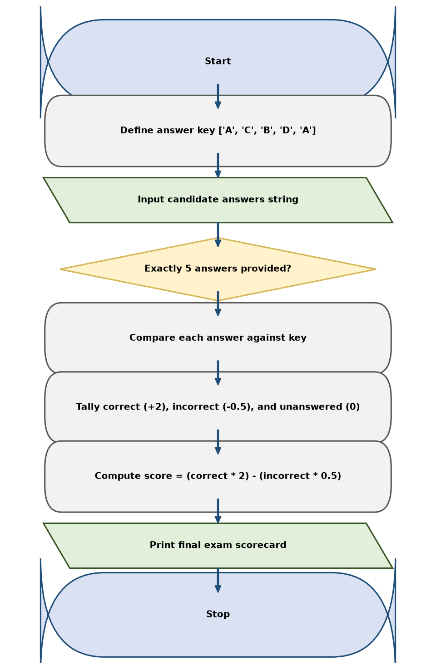
6. Pseudocode
BEGIN
answer_key ← ["A", "C", "B", "D", "A"]
INPUT answers_string
answers ← SPLIT_WORDS(UPPERCASE(answers_string))
IF length(answers) != 5 THEN
PRINT "Please enter exactly 5 answers."
ELSE
correct ← 0, incorrect ← 0, unanswered ← 0
FOR i ← 0 TO 4 DO
IF answers[i] = "-" THEN unanswered ← unanswered + 1
ELSE IF answers[i] = answer_key[i] THEN correct ← correct + 1
ELSE incorrect ← incorrect + 1
END FOR
score ← (correct * 2.0) - (incorrect * 0.5)
PRINT correct, incorrect, unanswered, score
END IF
END
7. Python Source Code
answer_key = ["A", "C", "B", "D", "A"]
answers = input("Enter 5 answers separated by spaces (use - for blank): ")
answers = answers.upper().split()
if len(answers) != 5:
print("Please enter exactly 5 answers.")
else:
correct = 0
incorrect = 0
unanswered = 0
for i in range(len(answer_key)):
if answers[i] == "-":
unanswered += 1
elif answers[i] == answer_key[i]:
correct += 1
else:
incorrect += 1
score = correct * 2 - incorrect * 0.5
print("\n--- Examination Result ---")
print("Correct answers:", correct)
print("Incorrect answers:", incorrect)
print("Unanswered:", unanswered)
print("Final score:", round(score, 2), "out of 10")
8. Test Cases
Test Case 1
Input: Answers: A C B D A
Expected result: Correct: 5, Incorrect: 0, Unanswered: 0 -> Final score: 10.0 out of 10
Test Case 2
Input: Answers: A C B - -
Expected result: Correct: 3, Incorrect: 0, Unanswered: 2 -> Final score: 6.0 out of 10
Test Case 3
Input: Answers: A B B D A
Expected result: Correct: 4, Incorrect: 1 (Q2 B vs C), Unanswered: 0 -> Final score: 7.5 out of 10
9. Output Screenshot
The following screenshot-style terminal capture shows the output produced by the supplied script.
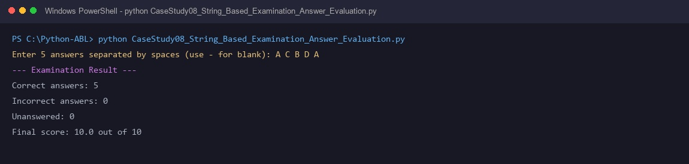
10. Conclusion
The objective examination evaluator automates academic test scoring with negative marking. It processes answer strings, detects omissions, and ensures impartial grading.

Case Study 42: Student Marks Matrix Analysis
1. Problem Statement
Academic administration systems maintain student test results in two-dimensional matrices across multiple subjects and require automated analytics to compute individual student averages, identify the top student, and calculate subject-wise cohort averages.
2. Objectives
- Represent marks for multiple students across Mathematics, Physics, and Programming.
- Calculate each student's average score across all subjects.
- Identify the highest-achieving student in the class cohort.
- Calculate class-wide subject averages for each discipline.
3. Assumptions
- Data is represented as a 2D matrix (students as rows, subjects as columns).
- Student roster: ['Asha', 'Ravi', 'Kiran'].
- Subject roster: ['Mathematics', 'Physics', 'Programming'].
- All marks are non-negative numeric scores out of 100.
4. Algorithm
- Initialize students list and subjects list.
- Initialize 2D marks matrix.
- For each student row, compute average = sum(row) / len(row).
- Track student with the highest average score.
- Display student averages and top performer.
- For each subject column, compute subject average across all students.
- Display cohort subject-wise averages.
5. Flowchart
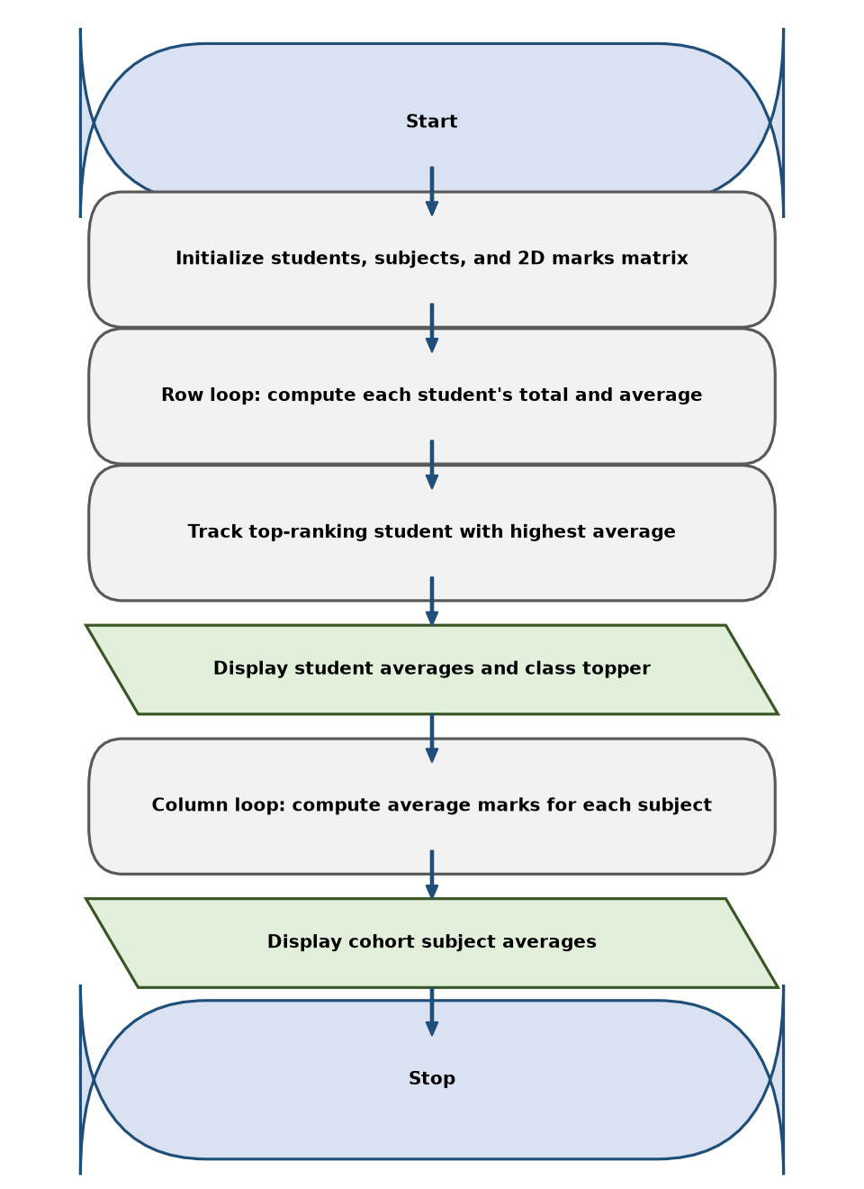
6. Pseudocode
BEGIN
students ← ["Asha", "Ravi", "Kiran"]
subjects ← ["Mathematics", "Physics", "Programming"]
marks ← [ [85, 78, 92], [67, 74, 70], [40, 52, 53] ]
highest_avg ← -1.0, top_student ← ""
PRINT "--- Student Averages ---"
FOR i ← 0 TO length(students)-1 DO
student_avg ← SUM(marks[i]) / length(subjects)
PRINT students[i], student_avg
IF student_avg > highest_avg THEN
highest_avg ← student_avg
top_student ← students[i]
END IF
END FOR
PRINT "Highest average:", top_student, highest_avg
PRINT "--- Subject Averages ---"
FOR j ← 0 TO length(subjects)-1 DO
subject_total ← 0
FOR i ← 0 TO length(students)-1 DO
subject_total ← subject_total + marks[i][j]
END FOR
PRINT subjects[j], subject_total / length(students)
END FOR
END
7. Python Source Code
students = ["Asha", "Ravi", "Kiran"]
subjects = ["Mathematics", "Physics", "Programming"]
marks = [
[85, 78, 92],
[67, 74, 70],
[45, 52, 48]
]
print("--- Student Averages ---")
student_averages = []
for i in range(len(students)):
average = sum(marks[i]) / len(marks[i])
student_averages.append(average)
print(students[i] + ":", round(average, 2))
top_index = student_averages.index(max(student_averages))
print("Highest average:", students[top_index],
"with", round(student_averages[top_index], 2))
print("\n--- Subject Averages ---")
for j in range(len(subjects)):
total = 0
for i in range(len(students)):
total += marks[i][j]
average = total / len(students)
print(subjects[j] + ":", round(average, 2))
if average < 50:
print(" Attention: average is below 50.")
8. Test Cases
Test Case 1
Input: Matrix: Asha [85, 78, 92], Ravi [67, 74, 70], Kiran [40, 52, 53]
Expected result: Asha: 85.0 (Topper), Ravi: 70.33, Kiran: 48.33; Math: 64.0, Physics: 68.0, Prog: 71.67
Test Case 2
Input: All students scored 80 across all subjects
Expected result: All student averages 80.0, All subject averages 80.0
Test Case 3
Input: Single student evaluation row
Expected result: Outputs student average and identical subject averages
9. Output Screenshot
The following screenshot-style terminal capture shows the output produced by the supplied script.
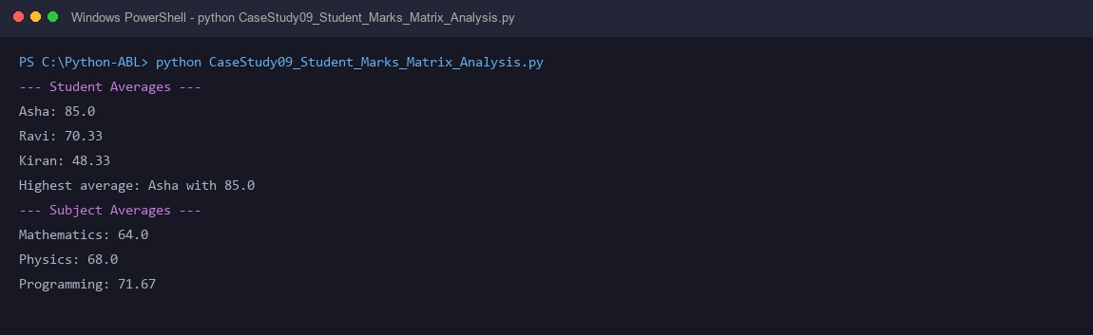
10. Conclusion
The marks matrix analysis tool demonstrates multi-dimensional array traversal. It enables academic administrators to aggregate student performance horizontally while measuring curriculum efficacy vertically.

Case Study 53: Food Waste Monitoring System
1. Problem Statement
Institutional campus dining halls and catering facilities must audit daily meal preparation against actual consumption to measure food wastage, flag excessive discard days, and promote sustainability.
2. Objectives
- Track daily prepared meals and served meals across weekdays.
- Compute leftover portions (prepared - served) for each day.
- Calculate daily food waste percentage = (leftovers / prepared) * 100.
- Issue waste threshold warnings if daily waste exceeds acceptable limit (10%).
- Calculate weekly cumulative food waste totals.
3. Assumptions
- Data is tracked for Monday, Tuesday, and Wednesday.
- Prepared meal counts and served meal counts are positive integers.
- Served meals cannot exceed prepared meals for any day.
- Acceptable wastage threshold is 10% of prepared food.
4. Algorithm
- Define days = ['Monday', 'Tuesday', 'Wednesday'].
- Define prepared = [100, 120, 90] and served = [92, 105, 85].
- Set acceptable_limit = 10% and total_waste = 0.
- Iterate i through each day:
- leftover = prepared[i] - served[i].
- waste_pct = (leftover / prepared[i]) * 100.
- total_waste += leftover.
- Display day's prepared, served, leftovers, and waste percentage.
- If waste_pct > acceptable_limit: display excessive waste warning.
- Print total weekly food waste summary.
5. Flowchart
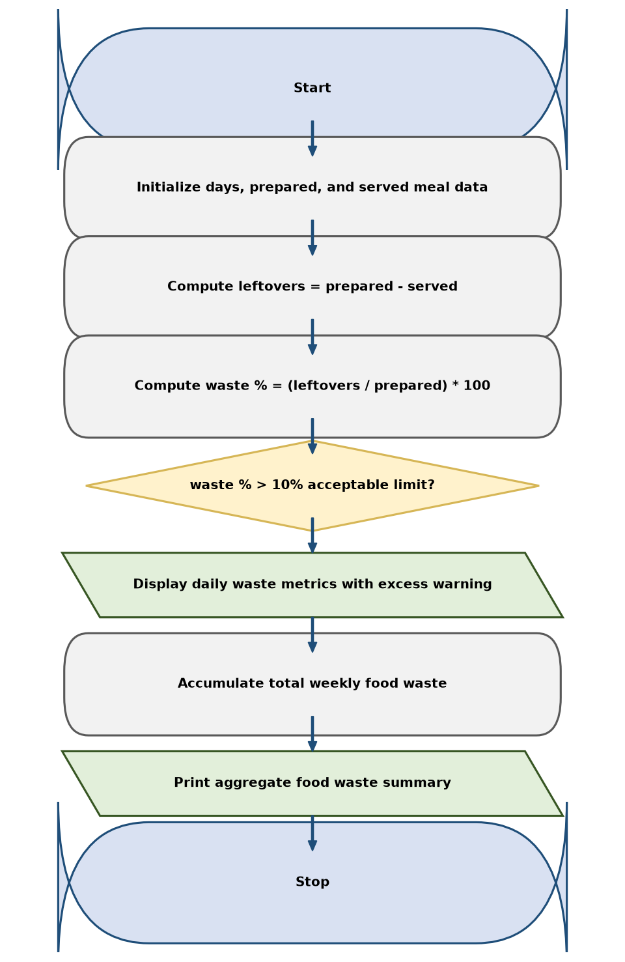
6. Pseudocode
BEGIN
days ← ["Monday", "Tuesday", "Wednesday"]
prepared ← [100, 120, 90]
served ← [92, 105, 85]
limit ← 10.0, total_waste ← 0
PRINT "--- Food Waste Report ---"
FOR i ← 0 TO length(days)-1 DO
leftover ← prepared[i] - served[i]
waste_pct ← (leftover / prepared[i]) * 100.0
total_waste ← total_waste + leftover
PRINT days[i], prepared[i], served[i], leftover, waste_pct
IF waste_pct > limit THEN
PRINT "Warning: Waste exceeded threshold (10%)"
END IF
END FOR
PRINT "Total leftovers for monitored days:", total_waste
END
7. Python Source Code
days = ["Monday", "Tuesday", "Wednesday"]
prepared = [100, 120, 90]
served = [92, 105, 85]
acceptable_limit = 10
total_waste = 0
print("--- Food Waste Report ---")
for i in range(len(days)):
if prepared[i] <= 0 or served[i] < 0 or served[i] > prepared[i]:
print(days[i] + ": Invalid meal counts.")
else:
leftovers = prepared[i] - served[i]
waste_percent = leftovers / prepared[i] * 100
total_waste += leftovers
print(days[i] + ":")
print(" Prepared:", prepared[i])
print(" Served:", served[i])
print(" Leftovers:", leftovers)
print(" Waste percentage:", round(waste_percent, 2), "%")
if waste_percent > acceptable_limit:
print(" Warning: waste is above 10%.")
print("Total leftover meals:", total_waste)
8. Test Cases
Test Case 1
Input: Mon: 100 prep, 92 served; Tue: 120 prep, 105 served; Wed: 90 prep, 85 served
Expected result: Mon: 8.0%, Tue: 12.5% (Warning), Wed: 5.56%, Total waste: 28 meals
Test Case 2
Input: All prepared meals completely served (100% consumption)
Expected result: Leftovers: 0, Waste %: 0.0%, Total waste: 0 meals
Test Case 3
Input: Half of prepared meals wasted (50% waste)
Expected result: Waste %: 50.0% -> Severe waste warning triggered
9. Output Screenshot
The following screenshot-style terminal capture shows the output produced by the supplied script.
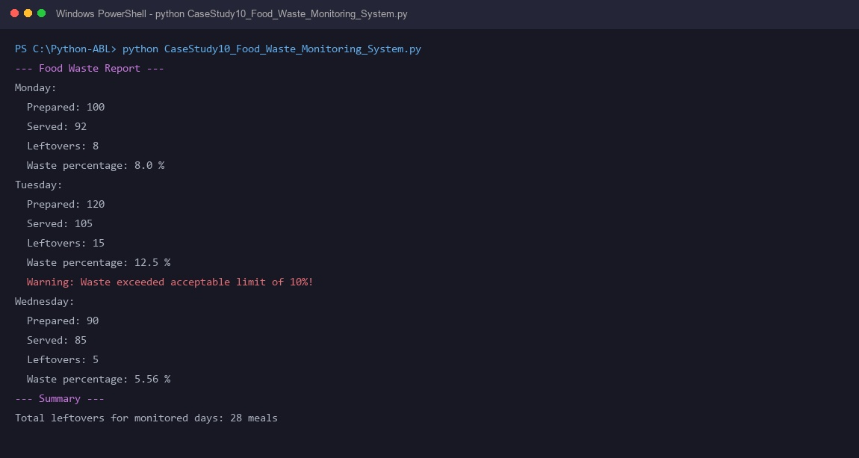
10. Conclusion
The food waste monitoring system applies daily metric tracking to institutional cafeteria logistics. By flagging excessive waste days, it supports sustainable kitchen management and reduces operational food losses.

